**OPERATING SYSTEM SERVICES**

The services provided by operating system are

1)User Interface.

2)Program Execution.

3)I/O operations.

4)File-system manipulation.

5)Communications.

6)Error detection.

7)Resource Allocation.

8)Accounting.

9)Protection and Security.

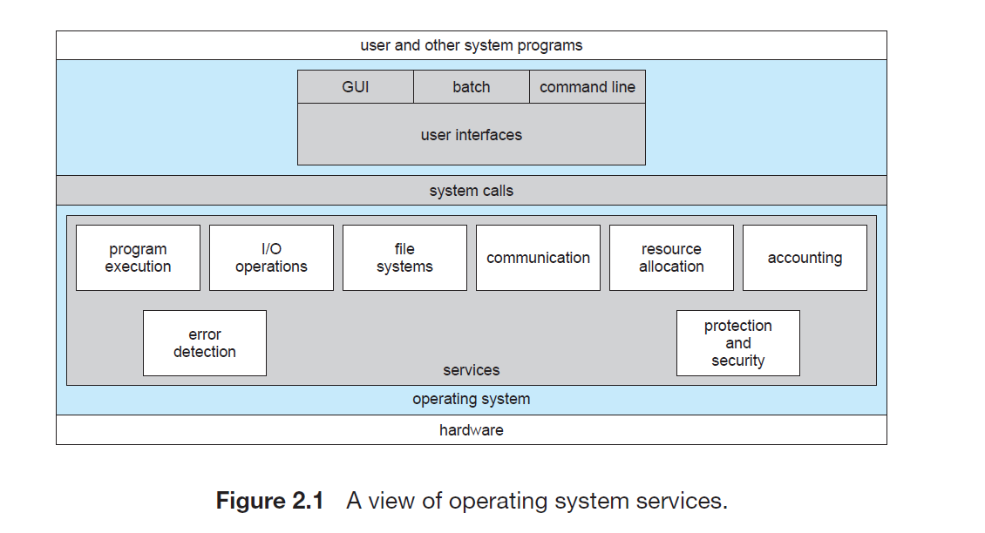

**1)User Interface:**

Almost all operating systems have a user interface (UI). The user interface is the service that practically enables users to interact with an operating system. This interface can take 3 forms:

i)Command-line interface (CLI)

ii)Batch interface

iii)Graphical User Interface (GUI).

Command-Line Interface commonly uses text commands input by the users to interact with the system. Another is Batch interface in which commands and directives are used to manage those commands that are entered into files and those files get executed. Most commonly, a graphical user interface (GUI) is used. A GUI usually consists of all the graphical icons displayed on a computer screen, visual indicators like widgets, texts, labels, and text navigation. Thus, a user can directly perform actions with a click of the mouse or keyboard.

**2)Program Execution:**

The OS loads a program into memory and then executes that program. It also makes sure that once started that program can end its execution, either normally or abnormally (indicating error).

**3)I/O operations:**

I/O operations are required during the execution of a program. To maintain efficiency and protection of the program, users cannot directly govern the I/O devices instead the OS allows to read or write operations with any file using the I/O devices and also allows access to any required I/O device when required.

**4)File-system manipulation:**

A program is read and then written in the form of directories and files. These files can be stored on the storage disk for the long term. The OS allows the users to create and delete files, duplicate these files, and search files and list their information or properties. It also does permission management for these files i.e., allowing or denying access to these files or directories based on the file ownership.

**5)Communications:**

One Process needs to exchange information with another process. Such communication may occur processes that are executing on same computer system or on different computer systems they are connected through communication lines in a network by using operating system support. Communication between two processes can be done using shared memory or via message passing.

**6)Error detection:**

Errors may occur in any of the resources like CPU, I/O devices, or memory hardware and in the user program. For each type of error, the OS should take appropriate action for ensuring correct and consistent computing.

**7)Resource Allocation:**

Resources can be CPU cycles, main memory storage, file storage and I/O devices. When there are multiple users or multiple jobs running at the same time, resources must be allocated to each of them. CPU scheduling routines are used here to establish how best the CPU can be used.

**8)Accounting:**

This service of the operating system keeps track of which users are using how much and what kinds of computer resources. This data is used to improve the performance of the operating system and minimize the response time of the system.

**9)Protection and Security:**

When several separate processes execute concurrently, it should not be possible for one process to interfere with the others or with the operating system itself. Protection involves ensuring that all access to system resources in a controlled manner.  For making a system secure, the user needs to authenticate himself or herself to the system before using usually by means of login ID and password, to gain access to system resources.